**MINI PROJECT ON**

**JOB PORTAL MANAGEMENT SYSTEM**

**A Project Report Submitted in Partial Fulfilment of the Requirements for the Degree of**

**BACHELOR OF TECHNOLOGY**

**in**

**Computer Science & Engineering**

**by**

**UTKARSH MEHRA (190013135095)**

**SHIKHAR SINGH (190013135080)**

**SAHIL SINGH (190013135074)**

**RISHABH TIWARI (190013135069)**

Under the Guidance of

**Dr. JASWANT KUMAR**



**FACULTY OF ENGINEERING AND TECHNOLOGY UNIVERSITY OF LUCKNOW, LUCKNOW.**

**2022 – 23**

**DECLARATION**

We hereby declare that this submission is our own work and that, to the best of our knowledge and belief, it contains no material previously published or written by another person or material which to a substantial extent has been accepted for the award of any other degree or diploma of the University or other institute of higher education, except where due acknowledgement has been made in the text.

**Signature**

**Student Name: Utkarsh Mehra**

**Univ. Roll. No.: 190013135095**

**Date:**

**Signature**

**Student Name: Shikhar Singh**

**Univ. Roll. No.: 190013135080**

**Date:**

**Signature**

**Student Name: Sahil Singh**

**Univ. Roll. No.: 190013135074**

**Date:**

**Signature**

**Student Name: RISABH TIWARI**

**Univ. Roll. No.: 190013135069**

**Date:**

**CERTIFICATE**

Certified that **Utkarsh Mehra** (190013135095)has carried out the mini project work presented in this project report entitled **“Job portal Management System”** for the award of **Bachelor of Technology** (Computer Science & Technology) from **Faculty of Engineering and Technology, University of Lucknow, Lucknow** under my guidance. The project report embodies results of original work, and studies are carried out by the student himself and the contents of the project report do not form the basis for the award of any other degree to the candidate or to anybody else from this or any other

University Of Lucknow /Faculty of Engineering and Technology.

Signature

Name of Guide**: Dr. Jaswant Kumar**

Designation: **Assistant Professor, FOET, University of Lucknow**

Place: Lucknow

**CERTIFICATE**

Certified that **Shikhar Singh** (190013135080)has carried out the mini project work presented in this project report entitled **“Job portal Management System”** for the award of **Bachelor of Technology** (Computer Science & Technology) from **Faculty of Engineering and Technology, University of Lucknow, Lucknow** under my guidance. The project report embodies results of original work, and studies are carried out by the student himself and the contents of the project report do not form the basis for the award of any other degree to the candidate or to anybody else from this or any other

University Of Lucknow /Faculty of Engineering and Technology.

Signature

Name of Guide**: Dr. Jaswant Kumar**

Designation**: Assistant Professor, FOET, University of Lucknow**

Place: Lucknow

**CERTIFICATE**

Certified that **Sahil Singh** (190013135074)has carried out the mini project work presented in this project report entitled **“Job portal Management System”** for the award of **Bachelor of Technology** (Computer Science & Technology) from **Faculty of Engineering and Technology, University of Lucknow, Lucknow** under my guidance. The project report embodies results of original work, and studies are carried out by the student himself and the contents of the project report do not form the basis for the award of any other degree to the candidate or to anybody else from this or any other

University Of Lucknow /Faculty of Engineering and Technology.

Signature

Name of Guide**: Dr. Jaswant Kumar**

Designation**: Assistant Professor, FOET, University of Lucknow**

Place: Lucknow

**CERTIFICATE**

Certified that **RISABH TIWARI** (190013135069)has carried out the mini project work presented in this project report entitled **“Job portal Management System”** for the award of **Bachelor of Technology** (Computer Science & Technology) from **Faculty of Engineering and Technology, University of Lucknow, Lucknow** under my guidance. The project report embodies results of original work, and studies are carried out by the student himself and the contents of the project report do not form the basis for the award of any other degree to the candidate or to anybody else from this or any other

University Of Lucknow /Faculty of Engineering and Technology.

Signature

Name of Guide**: Dr. Jaswant Kumar**

Designation**: Assistant Professor, FOET, University of Lucknow**

Place: Lucknow

**ACKNOWLEDGEMENT**

First of all, I am indebted to the GOD ALMIGHTY for giving me an opportunity to excel in my efforts to complete this seminar on time.

I am extremely grateful to **Prof. Alok Kumar Rai, Prof. A.K. Singh**, University of Lucknow and **Er. Zeeshan Ali Siddiqui**, Head of Department, Department of Computer Science and Engineering, for providing all the required resources for the successful completion of my MINI PROJECT.

My heartfelt gratitude to my mini project guide **Dr. Jaswant Kumar**, Computer Science and Engineering, for his valuable suggestions and guidance in the preparation of the mini project report.

I will be failing in duty if I do not acknowledge with grateful thanks to the authors of the references and other literatures referred to in this mini project.

Last but not the least; I am very much thankful to my parents who guided me in every step which I took.

**Utkarsh Mehra Shikhar Singh Sahil Singh**

(Roll No: 190013135095) (Roll No: 190013135080) (Roll No: 190013135074)

**RISABH TIWARI**

(Roll No: 190013135069)

**Abstract**

A college library management is a project that manages and stores books information electronically according to students needs. The system helps both students and library manager to keep a constant track of all the books available in the library. It allows both the admin and the student to search for the desired book. It becomes necessary for colleges to keep a continuous check on the books issued and returned and even calculate fine. This task if carried out manually will be tedious and includes chances of mistakes. These errors are avoided by allowing the system to keep track of information such as issue date, last date to return the book and even fine information and thus there is no need to keep manual track of this information which thereby avoids chances of mistakes.

**Modules:**

**Admin login:** Admin is the one who administers the system by adding or removing e-books into and from the system respectively.

**User login:** Students have to register themselves into the system to create an account. After registering successfully, they can then login into the system by entering 10 digit mobile number and their email id.

**Add and Update:** The admin can add to the system by entering the details of the Ccandidates and can even update the details.

**Search option:** Admin and Students can even search for books by entering the name of the book.

**View Order-**The admin can view order .

**Basic implementation tools:**

* HTML
* CSS
* Java Script
* Bootstrap
* VS Code

**Table of Contents**

Page No.

Declaration ii

Certificate iii Acknowledgement iv

Abstract v

**CHAPTER 1: INTRODUCTION 1-2**

1.1 OBJECTIVE 1

1.2 BACKGROUND OF PROJECT 1

1.3 OPREATION ENVIRONMENT 2

**CHAPTER 2: SYSTEM ANALYSIS 3-11**

2.1 FUNCTIONAL REQUIREMENTS 3

2.2 NON-FUNCTIONAL REQUIREMENTS 4

2.3 SOFTWARE REQUREMENTS 6

2.4 HARDWARE REQUREMENTS 7

2.5 TOOLS 9

**CHAPTER 3: SYSTEM DESIGN 12-13**

3.1 SYSTEM DIAGRAM 12

3.2 TABLE NAME AND ATTRIBUTES 13

**CHAPTER 4: PROJECT IMAGES 14-16**

4.1 SYSTEM LOGIN 14

4.2 HOME PAGE 15-16

**CHAPTER 5: CONCLUSION 17**

**CHAPTER 6: REFERENCES 18**

**INTRODUCTION**

This chapter gives an overview about the aim, objectives, background and operation

environment of the system.

**1.1 PROJECT AIMS AND OBJECTIVES**

The project aims and objectives that will be achieved after completion of this project are

discussed in this subchapter. The aims and objectives are as follows:

• Online issue

• Request column

• A separate column

• login page

• A search column

• A teacher login page where teacher can add any events being organized in the college

and important suggestions regarding books.

• Online notice board about the workshop.

**1.2 BACKGROUND OF PROJECT**

JOB PORTAL Management System is an application which refers to systems which are

generally small or medium in size. It is used by company to manage the hiring process using a

computerized system where he/she can record various transactions.

Student maintenance modules are also included in this system which would keep track of the students .

With this computerized system there will be no loss of book record or member record

which generally happens when a non-computerized system is used.

In addition, report module is also included in Management System. If user’s position is admin, the user is able to generate different kinds of reports like lists of students registered, issue and return reports.

All these modules are able to help to manage with more convenience and in a more efficient.

**1.3 OPERATION ENVIRONMENT**

|  |  |
| --- | --- |
| PROCESSOR | INTEL CORE PROCESSOR OR BETTER PERFORMANCE |
| OPERATING SYSTEM | WINDOWS VISTA ,WINDOWS7, UBUNTU |
| MEMORY | 1GB RAM OR MORE |
| HARD DISK SPACE | MINIMUM 3 GB FOR DATABASE USAGE FOR FUTURE |
| DATABASE | MY SQL |

**CHAPTER 2**

**SYSTEM ANALYSIS**

In this chapter, we will discuss and analyze about the developing process of JOB PORTAL Management System including software requirement specification (SRS) and comparison between existing and proposed system. The functional and non-functional requirements are included in SRS part to provide complete description and overview of system requirement before the developing process is carried out. Besides that, existing vs proposed provides a view of how the proposed system will be more efficient than the existing one.

**2.1 SOFTWARE REQUIREMENT SPECIFICATION**

**2.1.1 GENERAL DESCRIPTION**

**PRODUCT DESCRIPTION:**

JOB PORTAL Management System is a computerized system which helps users. It reduces the risk of paper work such as file lost, file damaged and time consuming. It can help user to manage the transaction or record more effectively and timesaving.

**PROBLEM STATEMENT:**

The problem occurred before having computerized includes:

**• File lost**: When computerized system is not implemented file is always lost because of human environment. Sometimes due to some human error there may be a loss of records.

**• File damaged:** When a computerized system is not their file is always lost due to

some accident like spilling of water by some member on file accidentally. Besides some natural disaster like floods or fires may also damage the files.

• **Difficult to search record:** When there is no computerized system there is always a difficulty in searching of records if the records are large in number.

• **Space consuming:** After the number of records become large the space for physical storage of file and records also increases if no computerized system is implemented.

• **Cost consuming:** as there is no computerized system the to add each record paper will be needed which will increase the cost for the management of library.

**2.1.2 SYSTEM OBJECTIVES**

• **Improvement in control and performance:** The system is developed to cope up with the current issues and problems of library. The system can add user, validate user and is also bug free.

**• Save cost** After computerized system is implemented less human force will be required to

maintain thus reducing the overall cost.

**• Save time** Search record by using few clicks of mouse and few search

keywords thus saving his valuable time.

**• Option of online Notice board** To provide a detailed description of workshops going in thecollege as well as in nearby colleges

**2.1.3 SYSTEM REQUIREMENTS**

**2.1.3.1 NON-FUNCTIONAL REQUIREMENTS**

**SYSTEM REQUIREMENT**

**EFFICIENCY REQUIREMENT:** When a job portal management system will be implemented and user will easily access , searching and transaction will be very faster.

**RELIABILITY REQUIREMENT:** The system should accurately perform member registration, member validation, report generation, transaction and search.

**USABILITY REQUIREMENT:** The system is designed for a user-friendly environment so that student and staff can perform the various tasks easily and in an effective way.

**ORGANIZATIONAL REQUIREMENT**

**IMPLEMENTATION REQUIREMNTS:** In implementing whole system it uses html in front end with PHP as server-side scripting language which will be used for database connectivity and the backend i.e., the database part is developed using MySQL.

**DELIVERY REQUIREMENTS:** The whole system is expected to be delivered in six months of time with a weekly evaluation by the project guide.

**2.1.3.2 FUNCTIONAL REQUIREMENTS**

**1. NORMAL USER**

**1.1 USER LOGIN**

This feature used by the user to login into system. They are required to enter user id and

password before they are allowed to enter the system. The user id and password will be verified and if invalid id is their user is allowed to not enter the system.

* User id is provided when they register
* The system must only allow user with valid id and password to enter the system
* The system performs authorization process which decides what user level can access too.
* The user must be able to logout after they finished using system.

**1.2 REGISTER NEW USER**

This feature can be performed by all users to register new user to create account.

* System must be able to verify information.
* System must be able to delete information if information is wrong

**1.4 SEARCH**

This feature is found in maintenance part. we can search based on id,

name, etc.

* System must be able to search the database based on select search type
* System must be able to filter book based on keyword entered
* System must be able to show the filtered in table view.

**1.6 EVENT ADDITION**

This feature allows teacher and student to add information about various workshops being

conducted in college and colleges nearby.

* System should be able to add detailed information about events.
* System should be able to display information on notice board available in the homepage of site.

**2.2 SOFTWARE AND HARDWARE REQUIREMENTS**

This section describes the software and hardware requirements of the system.

**2.2.1 SOFTWARE REQUIREMENTS**

* Operating system- Windows 7 is used as the operating system as it is stable and

supports more features and is more user friendly.

* Database MYSQL-MYSQL is used as database as it easy to maintain and retrieve

records by simple queries which are in English language which are easy to

understand and easy to write.

* Development tools and Programming language- HTML is used to write the whole

code and develop webpages with CSS, Java Script for styling work and PHP for

sever side scripting.

**2.2.2 HARDWARE REQUIREMENTS**

* Intel core i5 2nd generation is used as a processor because it is fast than other

processors an provide reliable and stable and we can run our pc for long time.

By using this processor, we can keep on developing our project without any

worries.

* Ram 1 GB is used as it will provide fast reading and writing capabilities and

will in turn support in processing.

**2.3 EXISTING VS PROPOSED SYSTEM**

* Existing system does not have any facility of teacher’s login or student login

whereas proposed system will have a facility of student login as well as

teacher’s login.

* Existing system does not have a facility of online reservation of books whereas

proposed system has a facility of online reservation of books.

* Existing system does not have any facility of online notice board were

description of workshops happening in our college as well as nearby colleges is

being provided.

* Existing system does not have any option of lectures notes uploaded by teachers

whereas proposed system will have this facility.

* Existing system does not have any facility to generate student reports as well

book issue reports whereas proposed system provides librarian with a tool to

generate reports.

* Existing system does not have any facility for book request and suggestions

where as in proposed system after logging in to their accounts student can

request books as well as provide suggestions to improve library.

**2.4 SOFTWARE TOOLS USED**

The whole Project is divided in two parts the front end and the back end.

**2.4.1 FRONTEND**

The front end is designed using of HTML, CSS, Java Script.

**HTML (HYPER TEXT MARKUP LANGUAGE)**

language for creating web pages and other information that can be displayed in a web browser.HTML is written in the form of HTML elements consisting of *tags* enclosed in angle brackets (like <html>), within the web page content. HTML tags most commonly come in pairs like <h1> and </h1>, although some tags represent *empty elements* and so are unpaired, for example <img>. The first tag in a pair is the *start tag*, and the second tag is the *end tag* (they are also called *opening tags* and *closing tags*). In between these tags web designers can add text, further tags, comments and other types of text-based content. The purpose of a web browser is to read HTML documents and compose them into visible or audible web pages. The browser does not display the HTML tags, but uses the tags to interpret the content of the page.HTML elements form the building blocks of all websites. HTML allows images and objects to be embedded and can be used to create interactive forms. It provides a means to create structured documents by denoting structural semantics for text such as headings, paragraphs, lists, links, quotes and other items. It can embed scripts written in languages such as JavaScript which affect the behavior of HTML web pages.

**CSS (CASCADING STYLE SHEETS)**

is a style sheet language used for describing the look and formatting of a document written in a markup language. While most often used to style web pages and interfaces written in HTML and XHTML, the language can be applied to any kind of XML document, including

plain XML, SVG and XUL. CSS is a cornerstone specification of the web and almost all web pages use CSS style sheets to describe their presentation.CSS is designed primarily to enable the separation of document content from document presentation, including elements such as the layout, colors, and fonts. This separation can improve content accessibility, provide more flexibility and control in the specification of presentation characteristics, enable multiple pages to share formatting, and reduce complexity and repetition in the structural content (such as by allowing for table less web design).CSS can also allow the same markup page to be presented in different styles for different rendering methods, such as on-screen, in print, by voice (when read out by a speech-based browser or screen reader) and on Braille-based, tactile devices. It can also be used to allow the web page to display differently depending on the screen size or device on which it is being viewed. While the author of a document typically links that document to a CSS file, readers can use a different style sheet, perhaps one on their own computer, to override the one the author has specified. However if the author or the reader did not link the document to a specific style sheet the default style of the browser will be applied.CSS specifies a priority scheme to determine which style rules apply if more than one rule matches against a particular element. In this so-called *cascade*, priorities or *weights* are calculated and assigned to rules, so that the results are predictable.

**JAVA SCRIPT (JS)**

is a dynamic computer programming language. It is most commonly used as part of web browsers, whose implementations allow client-side scripts to interact with the user, control the browser, communicate asynchronously, and alter the document content that is displayed. It is also being used in server-side programming, game development and the creation of desktop and mobile applications. JavaScript is a prototype-based scripting language with dynamic typing and has first- class functions. Its syntax was influenced by C. JavaScript copies many names and naming conventions from Java, but the two languages are otherwise unrelated and have very different semantics.

The key design principles within JavaScript are taken from the Self and Scheme programming languages. The application of JavaScript to use outside of web pages—for example, in PDF documents, site-specific browsers, and desktop widgets—is also significant. Newer and faster JavaScript VMs and platforms built upon them (notably Node.js) have also increased the popularity of JavaScript for server-side web applications.

**PHP**

PHPis a server-side scripting language designed for web development but also used as a general-purpose programming language. PHP is now installed on more than 244 million websites and 2.1 million web servers. Originally created by Rasmus Lerdorf in 1995, the reference implementation of PHP is now produced by The PHP Group. While PHP originally stood for *Personal Home Page*, it now stands for *PHP: Hypertext Pre-processor*, a recursive backronym. PHP code is interpreted by a web server with a PHP processor module, which generates the resulting web page: PHP commands can be embedded directly into an HTML source document rather than calling an external file to process data. It has also evolved to include a command-line interface capability and can be used in standalone graphical applications. PHP is free software released under the PHP License. PHP can be deployed on most web servers and also as a standalone shell on almost every operating system and platform, free of charge.

**2.4.2 BACKEND**

The back end is designed using MySQL which is used to design the databases.

**MySQL**

("My S-Q-L", officially, but also called "My Sequel") is (as of July 2013) the world's second most widely used open-source relational database management system (RDBMS). It is named after co-founder Michael Widenius daughter, My. The SQL phrase stands for Structured Query Language. The MySQL development project has made its source code available under the terms of the GNU General Public License, as well as under a variety of proprietary agreements. MySQL was owned and sponsored by a single for- profit firm, the Swedish company MySQL AB, now owned by Oracle Corporation. MySQL is a popular choice of database for use in web applications, and is a central component of the widely used LAMP open-source web application software stack (and other 'AMP' stacks). LAMP is an acronym for "Linux, Apache, MySQL, Perl/PHP/Python." Free-software-open-source projects that require a full-featured database management system often use MySQL. For commercial use, several paid editions are available, and offer additional functionality.

**CHAPTER 3**

**SYSTEM DESIGN**

**3.1 System Diagram:**

**Management**

**Super Admin**

**Admin**

**Candidate login**

1. **Add Admin**
2. **View Student/Admin**
3. **Approve Request**
4. **View Profile**

**CHAPTER 4**

**PROJECT IMAGES**

**4.1 Login:**

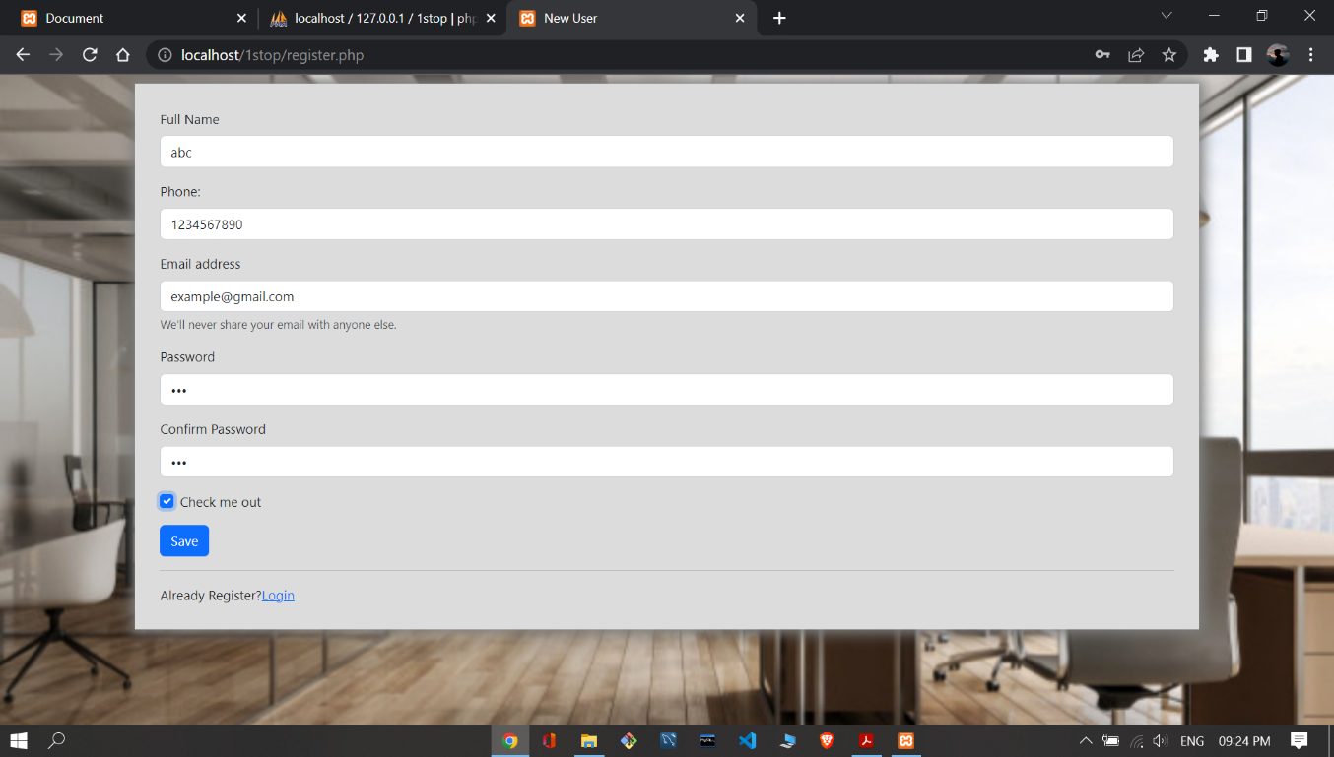

**4.2 Home Page:**

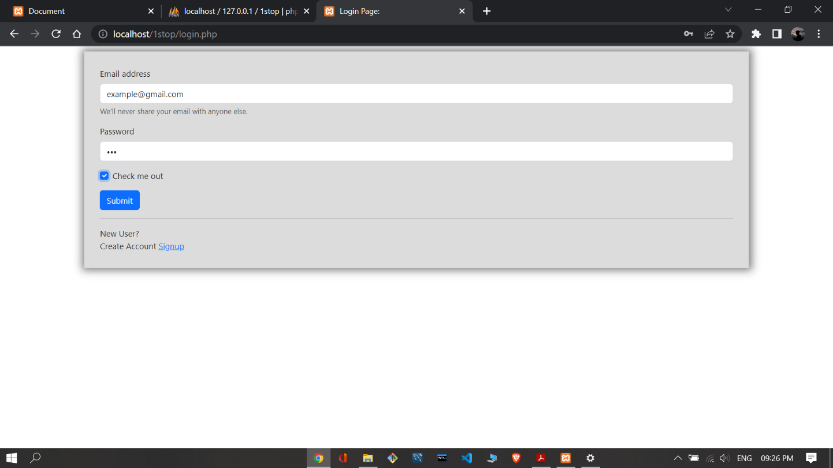

**4.3 Add Person** 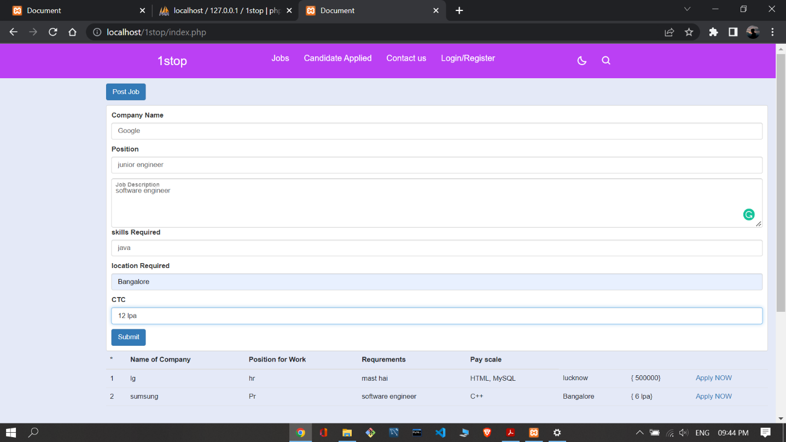

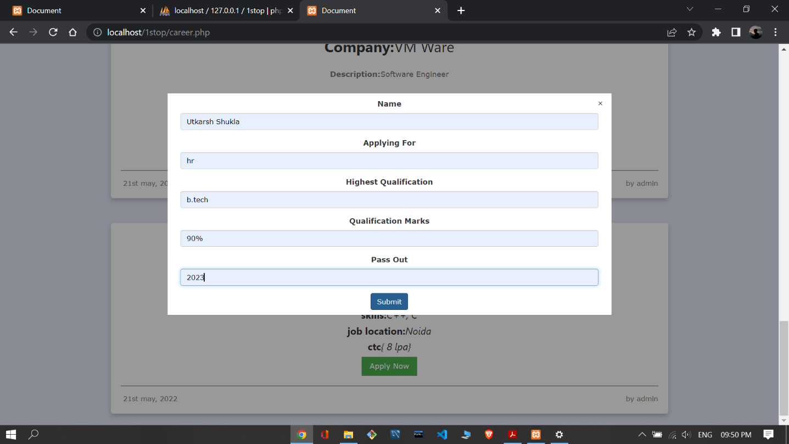

**CHAPTER 5**

**CONCLUSION**

A JOB PORTAL System is a project that tries to create an automated and computerised version for a hiring process so that the daily work of a portal can be managed and monitored easily and efficiently. Earlier, the companies used to manage the whole work in manual mode in the form of files and record books. Also, the process of adding new students had to be managed in a manual manner which is very slow and inefficient. The management system resolves this problem and provide a better solution to this. It provides a user-friendly interface application to the companies where he can do all the operations of hiring very easily. . The admin module will be managed by the system administrator. He manages the overall functioning of the application. Th module will be accessed by admin. He can perform various operations inside the application such as add new students to the database, issuing generating weekly/monthly reports etc. The student module can be accessed by the registered students only. These modules are interconnected with each other and also with the database. The application is built using Java technology and Sql database.

**CHAPTER 6**

* <https://raise.digital/services>
* <https://www.1stop.ai/>
* <https://www.google.com/>
* <https://www.geeksforgeeks.org/>
* <https://creately.com/lp/er-diagram-tool-online/>
* [**https://www.google.com/**](https://www.google.com/)
* [**https://www.youtube.com/**](https://www.youtube.com/)
* [**https://www.youtube.com/watch?v=BAtYQZxpmhs**](https://www.youtube.com/watch?v=BAtYQZxpmhs)